SDL Tutorial 1

Setting up SDL

To enable us to use the functionality that SDL provides we need to hook up the various files provided. These include code files, .dlls and .lib files. All can be downloaded from the SDL website at <http://www.libsdl.org/>, but are available on Blackboard.

1. Download the SDL files from Blackboard.
2. Open Visual Studio and create a new blank project.

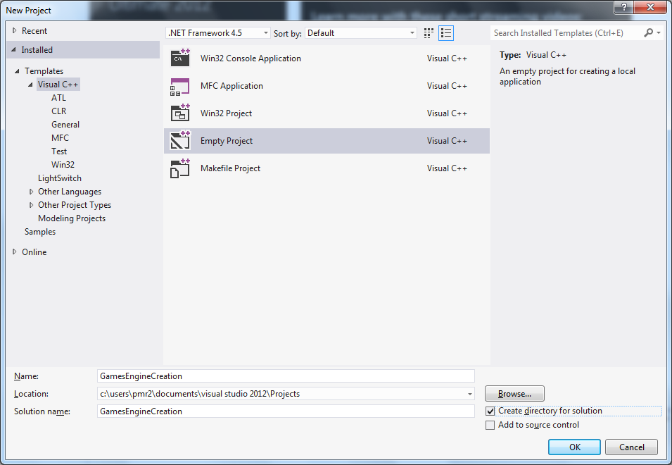

1. Locate your project in the file directory and place the SDL folder into the project folder.

*The project folder is the second folder in with the same name as your solution, the outer folder is the solution folder. i.e*

*Documents\MarioBaseProject(Solution folder)\MarioBaseProject(project folder)*

1. Create a Debug folder inside the solution folder and copy all the dll files in to it.
2. Back in Visual Studio Add a new source file and enter the following code:

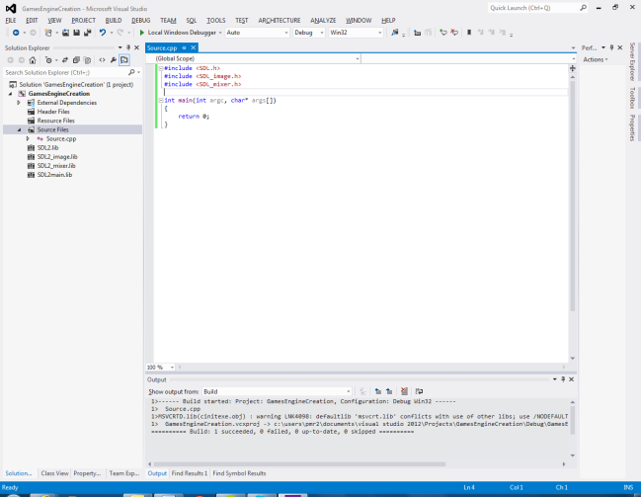

1. In visual Studio and right click the project and select properties. Make the following adjustments.
   1. Select C++ > and add all 3 of the include folders in the SDL folder as Additional Include Directories. Click Apply

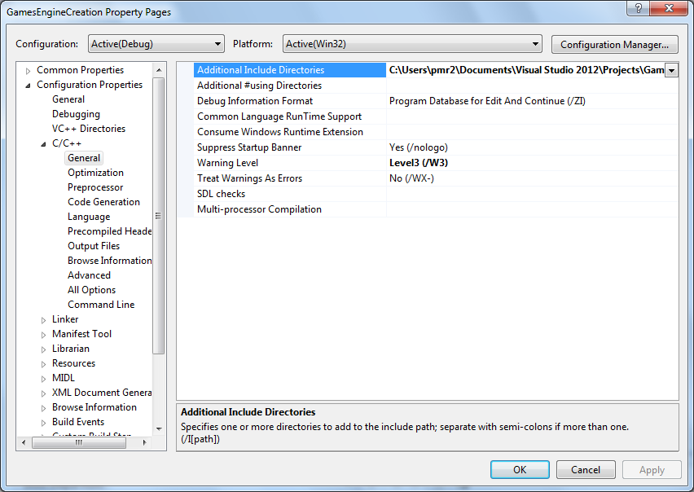

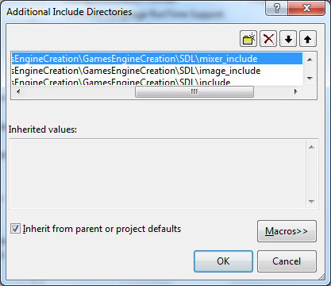

* 1. Select Linker > General and the SDL folder as an Additional Library Directories. Click Apply.

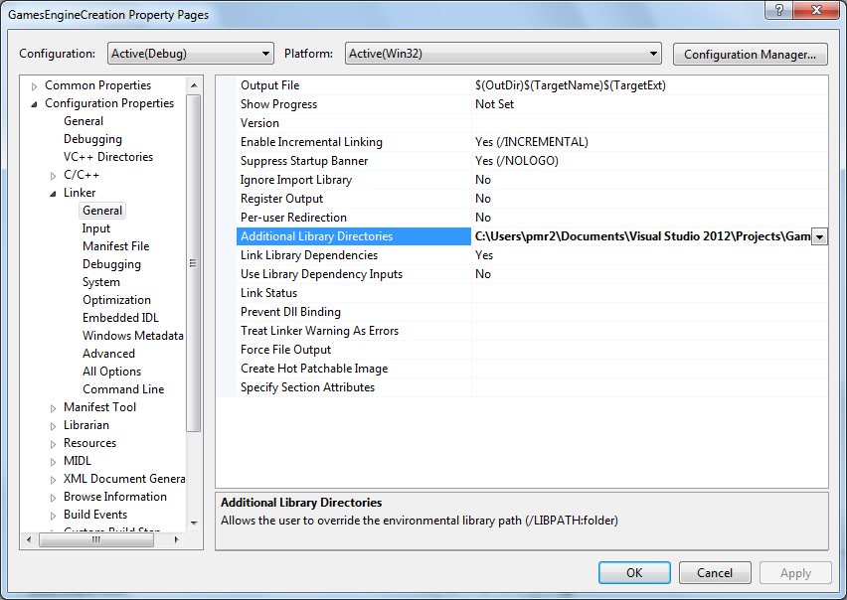

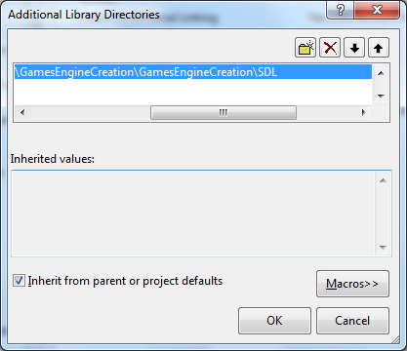

* 1. Finally, select Linker > System and ensure SubSystem is set to Console (SUBSYSTEM:CONSOLE). Click Apply, and click OK.

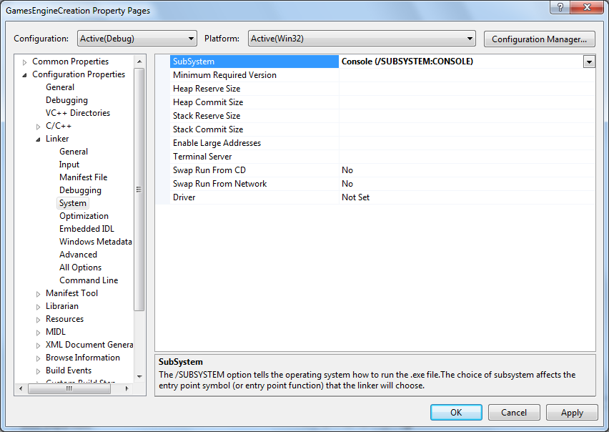

1. Now, right click the properties again and select Add > Existing Item...
   1. Add: SDL2.lb, SDL2_image.lib, SDL2_mixer.lib and SDL2_main.lib

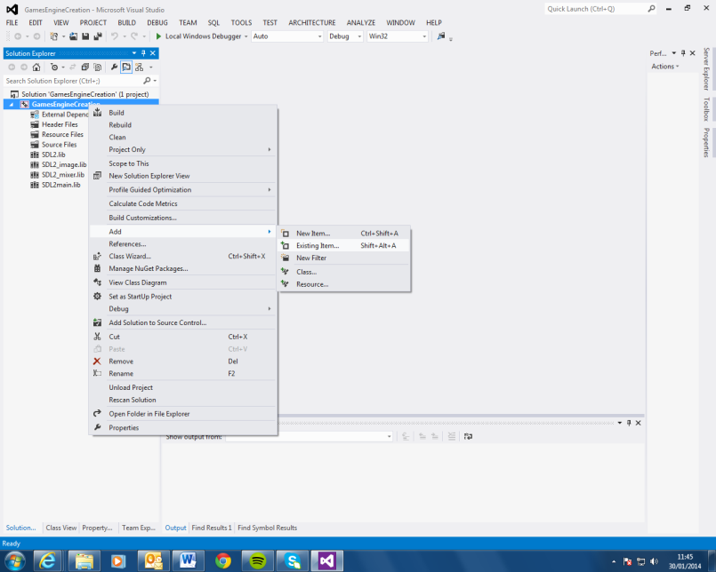

The main function must be entered in this format otherwise SDL will throw an Undefined Reference error.

1. Build the application. There should be no errors.
   1. If there are any errors at this point then you have made a mistake at one of the above steps. Go back and check that you have precisely followed the instructions.

SDL is now ready for use. Ensure that your project is saved somewhere safe that will not be lost. I suggest putting it on to a memory stick otherwise you will have to go through this process each time you start a new SDL project.

If you just copy the project across to a new location, be sure to change the paths for the additional include files and additional library files. Alternatively, go back through the paths you just set up and replace the path up to \SDL with $(PROJECTDIR). Your project will now run regardless of where you put it as your paths are set to the project directory.

For example:

$(PROJECTDIR)\SDL\image_include

In tutorial 2 we will look at opening a window.